FEEDBACK SYSTEM
SOFTWARE REQUIREMENT SPECIFICATIONS

Introduction:
FEEDBACK SYSTEM is a java web based application. It will mainly deal with the Feedback information in colleges. By using this application the students will sends feedbacks to administrator regarding their issues.
The main aim of "FEEDBACK SYSTEM" is to improve the services of students and parents. It maintains the details attendance of students and also updating for the same. It also stores the details of various users of the colleges, personal information and exam details of the student.

Purpose of SRS:
The purpose of this Software Requirement Specification (SRS) is to help the project. It is provided with some requirements which are used in Feedback System. All parts; design, coding and testing will be prepared with helping of SRS. The purpose of this document is to detail the requirements placed on the Feedback System. System and serves as a contract between the customer and the developers as to what is to be expected of the Feedback System, and how the components of the system are to work with each other with external systems.
This document will be checked by group member’s supervisor and it will corrected by members if supervisor orders.

Scope:
This application can not providing message alert for student and parents. In this project in future we will implement to get the message alerts to mobile students to get the username and password. Training for simple computer operations is necessary for the users working on the system.

Users of the system:
- Admin
- Student
- Faculity

Definitions, Acronyms and Abbreviations:

- SLA: Service Level Agreement or SLA is a formal written agreement made between two parties, the service provider & the service recipient. It defines the term of engagement - the fundamental rules that will govern the relationship.
- JAVA: Java is internet software which is used to develop distributed /web applications and it’s also integral to the intranet applications and other e-business solutions that are the foundation of corporate computing.
- Database (Oracle 10g): A database is a collection of information that is organized so that it can easily be accessed, managed and updated.
- Apache Tomcat server: Apache Tomcat is an open source servlet container developed by the Apache Software Foundation (ASF). Tomcat implements the Java Servlet and the JavaServer Pages (JSP) specifications from Sun Microsystems and provides a "pure Java" HTTP web server environment for Java code to run.
- SRS: Software Requirement Specification.

Reference:
- IEEE Standard Format for SRS.
- XML 1.1 Bible
- http://www.sun.com
- http://www.oracle.com/technetwork/java/index.html
- http://w3schools.com

Technologies to be used:
- Programming languages:
- JAVA: java technology is a high-level programming and a platform independent language. Java is designed to work in the distributed environment on the Internet.
- Tools & Development Environment:
- Operating System : Microsoft Windows XP/2000 or Higher
- Servers: Apache Tomcat
- Data Base Server : ORACLE 10g
- Client Browser: Any Browser (IE, Mozilla Firefox etc….).
- Development Tools: Net Beans 6.8.
- Documentation Tools: MS Office 2003/2007
- Drawing Tools: IBM Rational Rose Enterprise, MS Office Visio 2007
- User Interface: HTML,CSS & JAVA SCRIPT
- Code Behind: JSE, JEE.
Software Interface:
- Client: Any Browser (IE, Mozilla Firefox etc….).
- Database Server: Oracle10g.
- Development End: NetBeans 6.8.

Hardware Requirements:
Client Side
 | Processor | RAM | Disk Space
CONSOLE | Computer with a 2.6GHz processor or higher (Pentium processor recommended) | 512MB Minimum | Minimum 20 GB
Server Side
Apache Tomcat | Intel Pentium processor at 2.6GHz or faster | Minimum 512 MB Physical Memory; 1 GB Recommended | Minimum 20 GB
NetBeans 6.8  Oracle10g | Intel Pentium Processor at  2.6GHz or faster | Minimum 512 MB Physical Memory; (1 GB Recommended) | Minimum 20 GB

Communication Interface:
- Access of the CMS through Internet will be using HTTP/HTTPS protocol.

Existing System:

In the existing system the faculties have to take care of the students and collect all the feedback details and verification has to be taken manually.The existing system is manual and the manual system works in the following way:
Limitations of the Existing system:

- The faculty of particular department can assign because of that its take more time consuming to the faculty as well as student.
- If any personal details related to the student/staff have been tainted then the details has to be submitted to the college.
- If any personal details related to the student have been changed then the details has to be submitted to the College. This process is to be taken manually.
- Within a College the interactions between Principal (Admin), Faculties and the Students have been done manually.
Till now most of the schools has adopted the above manual system that produces lot of problems and at the same time the following disadvantages are there with the above system.

- The increasing complexity,
- producing the reports as desired is not possible,
- it is Manual system so it is time consuming

Proposed Systems:

To overcome all the difficulties of the existing system the management has proposed automated the whole system and the development of the new automated system contains the following activities, which try to automate the entire process keeping in view of the database integration approach.

Advantages of Proposed System:

- By developing this system we can provide better security to our data And reports will be gained accurately.
- Administrator is able to view create the faculty, students and he is also able to view the students and the faculty members also.
- It provides complete activity as automated system.
- It is not limited to a single system because it is aimed to develop for web based environment.
- The student information is available to the administrator and also to the faculty.

Functional Requirements:

The services that this system should support for these users are summarized below:
This system should provide the administrator with the convenience such as adding a new faculty, view and manage the information about the faculty; students view the next information:
- Admin maintain all the information about the project.
- Admin can add the students’ details and staff details.
- Admin can add department, view the staff details, and student details.
- Admin view the staff feedbacks and search the feedbacks by branch-wise, year-wise, and semester-wise.
This system should help the Faculty also.
- Faculty can login by user id and password.
- Faculty can view the self details and search the feedback details by year-wise, semester-wise, and branch-wise.

This system should help the student’s also.
- Student can login by the student id and password
- Student can view the self details and send to the feedbacks to administrator.

Non-Functional Requirements:
The system should be web-based system. Users should use the system via internet. Each user should have a user account. The system should ask the username and password to users. It doesn’t permit to unregistered user to access for Insurance on Internet. The system should have Role based System functions access. Approval Process has to be defined. The system should have Modular customization components so that they can be reused across the implementation.
These are the mainly following:
- 24 X 7 availability
- Better component design to get better performance at peak time
- Flexible service based architecture will be highly desirable for future extension
Interfaces
It provides the interface for accessing the database and also allows the user to do the manipulations on the databases.
Reliability
This entire project is depends on the SQL Server.
Accuracy
Since the same table is created at different users Biils, the
Possibility of retrieving data wrongly increases. Also if the data is more,
Validations become difficult. This may result in loss of accuracy of data.
Easy of Use
Ever user should be comfortable of working with computer and internet browsing. He must have basic knowledge of English.
Interoperability
This provides the import and export facilities for sending one database to another database.
Maintainability

The key to reducing need for maintenance, while working, if possible to do essential tasks.
More accurately defining user requirement during system development.
Assembling better systems documentation.
Using more effective methods for designing, processing, login and communicating information with project team members.
Making better use of existing tools and techniques.
Managing system engineering process effectively.
Testability:
Testing is done in various ways such as testing the algorithm, programming code; sample data debugging is also one of following the above testing.

Study of the System:

To provide flexibility to the users, the interfaces have been developed that are accessible through a browser. The GUI’S at the top level have been categorized as

Modules:

After looking at the functional requirements it is identified that we can divide the system into mainly following modules:

- Admin Module
- Student Module
- Lecturer Module
Administrators:
It equipped features makes it possible to create faculty, students, view the students and view the faculties.

Student Module:-

This module maintains the information related to the Feedbacks and Self details.

Faculty Module:

This module maintains the information related to the search feedbacks by year-wise, branch-wise, and semester-wise.

SDLC METHODOLOGIES:

This document play a vital role in the development of life cycle (SDLC) as it describes the complete requirement of the system. It means for use by developers and will be the basic during testing phase. Any changes made to the requirements in the future will have to go through formal change approval process.
SPIRAL MODEL was defined by Barry Boehm in his 1988 article, “A spiral Model of Software Development and Enhancement. This model was not the first model to discuss iterative development, but it was the first model to explain why the iteration models.
As originally envisioned, the iterations were typically 6 months to 2 years long. Each phase starts with a design goal and ends with a client reviewing the progress thus far. Analysis and engineering efforts are applied at each phase of the project, with an eye toward the end goal of the project.
The steps for Spiral Model can be generalized as follows:
The new system requirements are defined in as much details as possible. This usually involves interviewing a number of users representing all the external or internal users and other aspects of the existing system.
A preliminary design is created for the new system.
A first prototype of the new system is constructed from the preliminary design. This is usually a scaled-down system, and represents an approximation of the characteristics of the final product.
A second prototype is evolved by a fourfold procedure:
Evaluating the first prototype in terms of its strengths, weakness, and risks.
Defining the requirements of the second prototype.
Planning a designing the second prototype.
Constructing and testing the second prototype.
At the customer option, the entire project can be aborted if the risk is deemed too great. Risk factors might involve development cost overruns, operating-cost miscalculation, or any other factor that could, in the customer’s judgment, result in a less-than-satisfactory final product.

The existing prototype is evaluated in the same manner as was the previous prototype, and if necessary, another prototype is developed from it according to the fourfold procedure outlined above.
The preceding steps are iterated until the customer is satisfied that the refined prototype represents the final product desired.
The final system is constructed, based on the refined prototype.
The final system is thoroughly evaluated and tested. Routine maintenance is carried on a continuing basis to prevent large scale failures and to minimize down time.

- The following diagram shows how a spiral model acts like:
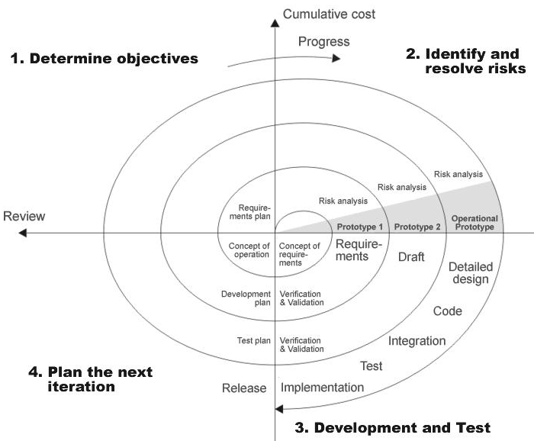Fig 1.0: Spiral Model

The developer is responsible for:
- Developing the system, this meets the SRS and solving all the requirements of the system.
- Demonstrating the system and installing the system at client's location after the acceptance testing is successful.
- Submitting the required user manual describing the system interfaces to work on it and also the documents of the system.
- Conducting any user training that might be needed for using the system.
- Maintaining the system for a period of one year after installation.

CONTEXT DIAGRAM: (0 Levels DFD)

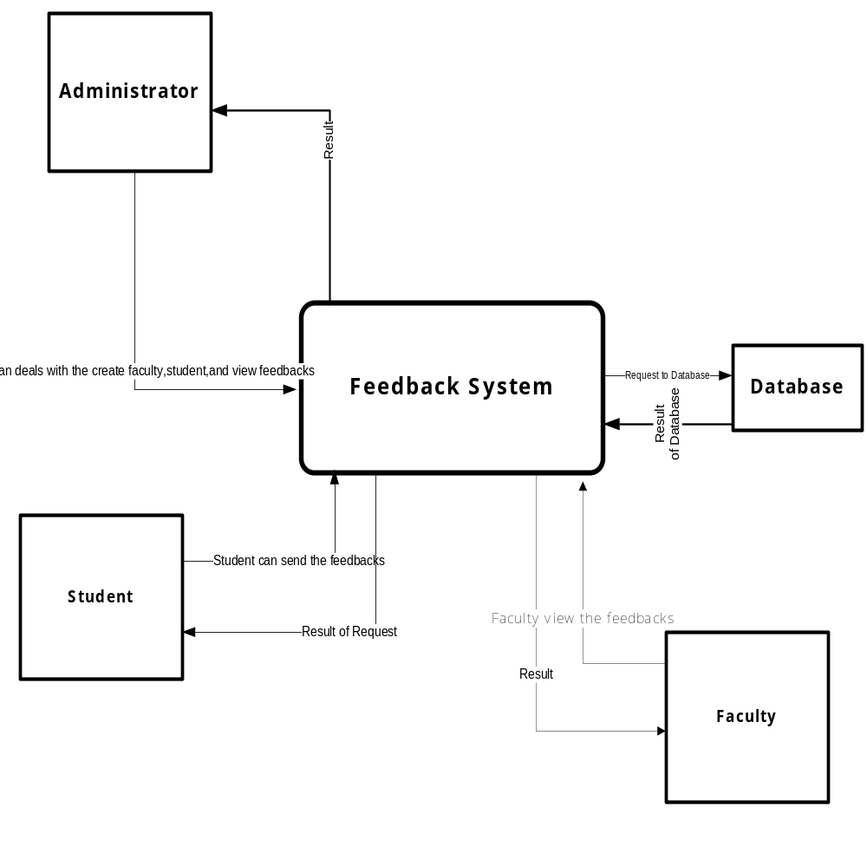

APPLICATION DEVELOPMENT ARCHITECTURE: To develop an application we use N-Tier Architecture.

N-Tier Architecture:
Can easily implement the concepts of Distributed Application Design and Architecture. The N-Tier Architecture provides strategic benefits to Enterprise Solutions. While 2-tier, client-server can help us create quick and easy solutions and may be used for Rapid Prototyping, they can easily become a maintenance and security night mare
The N-tier Applications provide specific advantages that are vital to the business continuity of the enterprise. Typical features of a real life n-tier may include the following:
- Security
- Availability and Scalability
- Manageability
- Easy Maintenance
- Data Abstraction
The above mentioned points are some of the key design goals of a successful n-tier application that intends to provide a good Business Solution.

Definition:

Simply stated, an n-tier application helps us distribute the overall functionality into various tiers or layers:
- Presentation Layer
- Business Rules Layer
- Data Access Layer
- Database/Data Store
Each layer can be developed independently of the other provided that it adheres to the standards and communicates with the other layers as per the specifications.

This is the one of the biggest advantages of the n-tier application. Each layer can potentially treat the other layer as a ‘Block-Box’.

In other words, each layer does not care how other layer processes the data as long as it sends the right data in a correct format.

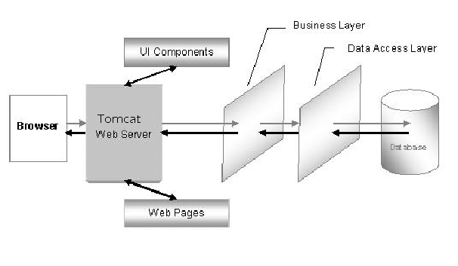

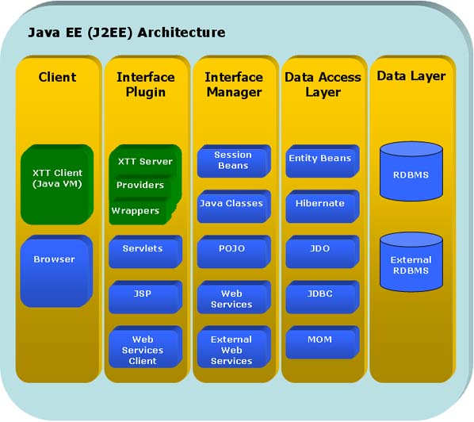

Fig -N-Tier Architecture
- The Presentation Layer:
It is also called as the client layer comprises of components that are dedicated to presenting the data to the user. For example: Windows/Web Forms and buttons, edit boxes, Text boxes, labels, grids, etc.
- The Business Logic Layer:
This layer encapsulates the Business rules or the business logic of the encapsulations. To have a separate layer for business logic is of a great advantage. This is because any changes in Business Rules can be easily handled in this layer. As long as the interface between the layers remains the same, any changes to the functionality / processing logic in this layer can be made without impacting the others. A lot of client-server apps failed to implement successfully as changing the business logic was a painful process.

- The Data Access Layer:
This layer comprises of components that help in accessing the Database. If used in the right way, this layer provides a level of abstraction for the database structures. Simply put changes made to the database, tables, etc do not affect the rest of the application because of the Data Access layer. The different application layers send the data requests to this layer and receive the response from this layer.
- The Database Layer:
This layer comprises of the Database Components such as DB Files, Tables, Views, etc. The Actual database could be created using SQL Server, Oracle, Flat files, etc. In an n-tier application, the entire application can be implemented in such a way that it is independent of the actual Database. For instance, you could change the Database Location with minimal changes to Data Access Layer. The rest of the Application should remain unaffected

PERFORMANCE REQUIREMENTS:

Performance is measured in terms of the output provided by the application. Requirement specification plays an important part in the analysis of a system. Only when the requirement specifications are properly given, it is possible to design a system, which will fit into required environment. It rests largely in the part of the users of the existing system to give the requirement specifications because they are the people who finally use the system. This is because the requirements have to be known during the initial stages so that the system can be designed according to those requirements. It is very difficult to change the system once it has been designed and on the other hand designing a system, which does not cater to the requirements of the user, is of no use.

The requirement specification for any system can be broadly stated as given below:

- The system should be able to interface with the existing system
- The system should be accurate
- The system should be better than the existing system

The existing system is completely dependent on the user to perform all the duties.

FEASIBILITY REPORT:
Preliminary investigation examine project feasibility, the likelihood the system will be useful to the organization. The main objective of the feasibility study is to test the Technical, Operational and Economical feasibility for adding new modules and debugging old running system. All system is feasible if they are unlimited resources and infinite time.

There are aspects in the feasibility study portion of the preliminary investigation:

- Technical Feasibility
- Operation Feasibility
- Economical Feasibility

Technical Feasibility
The technical issue usually raised during the feasibility stage of the investigation includes the following:

- Does the necessary technology exist to do what is suggested?
- Do the proposed equipments have the technical capacity to hold the data required to use the new system?
- Will the proposed system provide adequate response to inquiries, regardless of the number or location of users?
- Can the system be upgraded if developed?
- Are there technical guarantees of accuracy, reliability, ease of access and data security?

Earlier no system existed to cater to the needs of ‘Secure Infrastructure Implementation System’. The current system developed is technically feasible. It is a web based user interface for Online Project Management. Thus it provides an easy access to the users. The database’s purpose is to create, establish and maintain a workflow among various entities in order to facilitate all concerned users in their various capacities or roles. Permission to the users would be granted based on the roles specified. Therefore, it provides the technical guarantee of accuracy, reliability and security. The software and hard requirements for the development of this project are not many and are already available in-house or are available as free as open source. The work for the project is done with the current equipment and existing software technology. Necessary bandwidth exists for providing a fast feedback to the users irrespective of the number of users using the system.

Operational Feasibility

Proposed projects are beneficial only if they can be turned out into information system. That will meet the organization’s operating requirements. Operational feasibility aspects of the project are to be taken as an important part of the project implementation. Some of the important issues raised are to test the operational feasibility of a project includes the following: -

- Is there sufficient support for the management from the users?
- Will the system be used and work properly if it is being developed and implemented?
- Will there be any resistance from the user that will undermine the possible application benefits?

This system is targeted to be in accordance with the above-mentioned issues. Beforehand, the management issues and user requirements have been taken into consideration. So there is no question of resistance from the users that can undermine the possible application benefits.
The well-planned design would ensure the optimal utilization of the computer resources and would help in the improvement of performance status.

Economic Feasibility
A system can be developed technically and that will be used if installed must still be a good investment for the organization. In the economical feasibility, the development cost in creating the system is evaluated against the ultimate benefit derived from the new systems. Financial benefits must equal or exceed the costs. The system is economically feasible. It does not require any addition hardware or software. Since the interface for this system is developed using the existing resources and technologies available at NIC, There is nominal expenditure and economical feasibility for certain.

